Literacy support worksheet answers

5.1 The Earth’s spheres are balanced

Pages 112–115

Layers of Earth

1 Label the diagram below with the following: crust, mantle, outer core, inner core. (Hint: Use Figure 5.1 in the student book as a guide, but try to do it yourself first.)

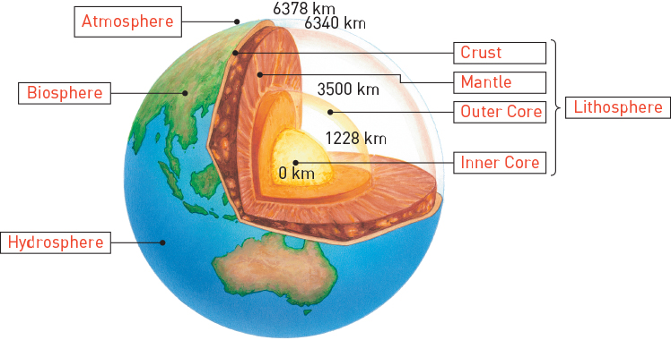

2 Now on the same diagram, add the labels for lithosphere, atmosphere, biosphere and hydrosphere.

3 Add lithosphere, atmosphere, hydrosphere or biosphere next to the correct description in the table below. The first row has been done for you.

|  |  |  |  |
| --- | --- | --- | --- |
| What is it? | Lithosphere, atmosphere, hydrosphere or biosphere? | What is it made of? | Lithosphere, atmosphere, hydrosphere or biosphere? |
| The Earth’s water, which resides in the oceans, lakes, glaciers, soil and air | Hydrosphere | Rock, magma, iron | Lithosphere |
| All the living things on the Earth, including plants, animals and bacteria | Biosphere | Water – H2O | Hydrosphere |
| The layers of the Earth | Lithosphere | Nitrogen, oxygen, carbon dioxide, water vapour, ozone | Atmosphere |
| The layers of gases that form the air | Atmosphere | Carbon based organisms | Biosphere |

4 Using numbers 1 to 3, order the information below detailing how the spheres affect each other.

2The atmosphere (air) and hydrosphere (solid, liquid and gaseous water) influence temperature and climate in the mountains, deserts and ocean currents.

3 The three spheres then all affect living organisms in the biosphere. A balance must be maintained to ensure balance on the planet.

1 The solid crust of the Earth (lithosphere) reacts with the atmosphere (air) and hydrosphere (solid, liquid and gaseous water).

Word detective – Draw and label

5 This diagram of the inputs and outputs of the Earth’s living and non-living systems is from page 115 of the student book, but it is missing the labels and arrows.

Draw the arrows and label the inputs and outputs of the Earth’s living and non-living systems, including carbon dioxide, food, oxygen, water vapour, nutrients, weather and so on. Try to complete it yourself. (Hint: Use Figure 5.4 in the student book as a guide, but try to do it yourself first.)

Student diagrams will vary, but will include similar diagrams to those in Figure 5.4.

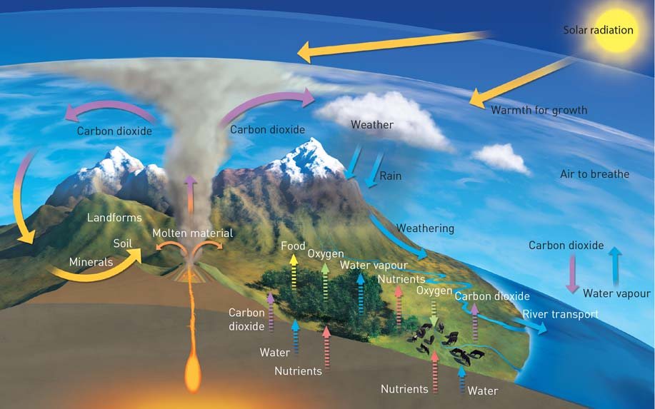

Literacy support worksheet answers

5.2 Matter cycles through the Earth’s spheres

Pages 116–119

The nutrient cycles

1 Name the three reservoirs of oxygen.

• the atmosphere

• the Earth’s crust or lithosphere – rocks and the oceans

• living organisms – the biosphere

2 Complete the following sentence:

‘Oxygen exists in the atmosphere as O2, O3 and compounds (like H2O).’

3 Fill in the blanks in the sentences below.

a In the biosphere, photosynthesis releases oxygen and cellular respiration absorbs oxygen.

b In the atmosphere, UV light converts water into hydrogen and oxygen. Oxygen is removed from the atmosphere through the process of cellular respiration, the decay of organisms and the weathering of rocks.

4 Nitrogen helps form the building blocks for life. What are these two building blocks?

proteins and nucleic acids

5 List the three usable forms of nitrogen that bacteria return to the atmosphere.

• nitrate ions

• nitrite ions

• ammonium ions

6 What can excessive use of fertilisers near reefs cause?

It can cause bleaching of the reefs.

7 Phosphorus is an essential component in which energy molecule?

ATP (adenosine triphosphate)

8 Most phosphorus available to living organisms comes in which two forms?

sedimentary rocks and soils

9 What is the key difference between the phosphorus cycle and the other main cycles?

There is no gaseous phase in the phosphorus cycle.

Word detective – Sequencing

10 Using numbers 1 to 4, order the information below detailing the phosphorus cycle.

4 Phosphorus is locked in sediments and rocks for millions of years until it is released by weathering and erosion.

3 Phosphorus is absorbed by organisms and is returned to the soil via urine, faeces and the decomposition of the organism.

1 Rain weathers rocks, releasing phosphate ions into the soil.

2 Plants absorb phosphate ions via their roots, enabling phosphorus to enter the food chain.

Literacy support worksheet answers

5.3 The water cycle is a global cycle

Pages 120–123

The water cycle

1 Draw a simplified diagram of the water cycle in the space below. (Hint: Use Figure 5.11 in the student book as a guide, but try to do it yourself first.)

You must include the following words: precipitation, evaporation, condensation, transpiration, oceans, on-shore winds, surface run-off

Student diagrams will vary, but will include similar diagrams to those in Figure 5.11. Diagram should be based on the water cycle and must include transpiration, which should show water evaporating from plant leaves into the atmosphere.

2 Below is a diagram of air movement. The following paragraph explains how movement of air at the Equator works, but it has some information missing. Fill in the blanks in the paragraph below so the information is complete. (Hint: Use Figure 5.12 in the student book as a guide, but try to do it yourself first.)

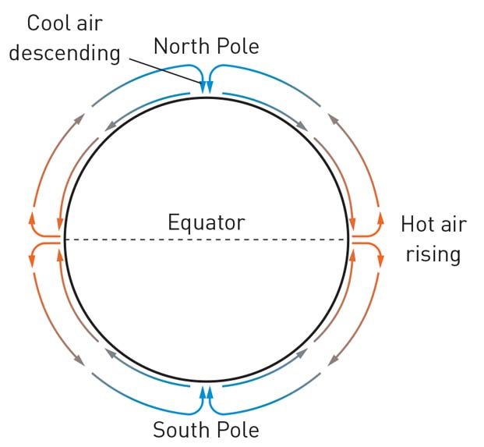

Hot air rises at the Equator as it has the most access to the sun. When air particles heat up, they increase their movement, (kinetic energy), spread further apart, and become less dense. As a result, these warmer air particles rise above the cool air. When they reach the poles they cool, lose kinetic energy, get closer together, become more dense and fall.

3 Fill in the missing definitions on the weather map below. Two have been filled in for you.

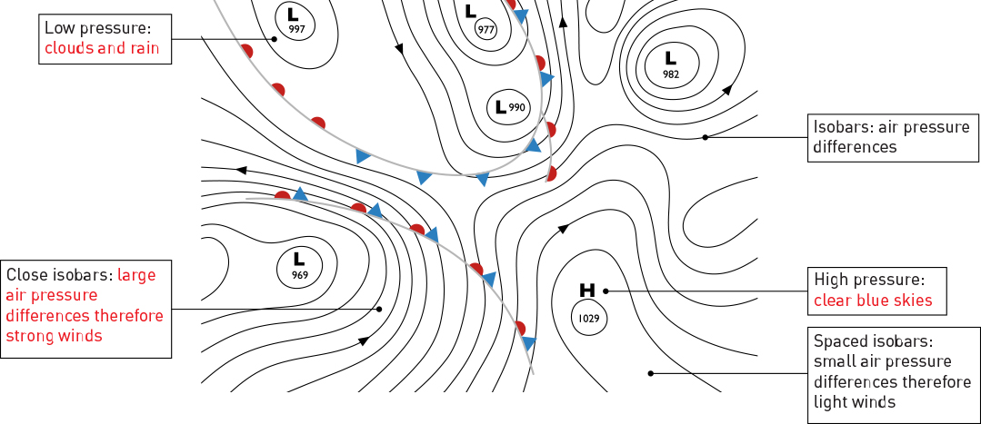

Word detective – Holiday weather

4 Visit the Bureau of Meteorology (BOM) website, and research the weather for one of Australia’s capital cities where you would like to visit: Melbourne, Sydney, Canberra, Brisbane, Perth, Adelaide or Darwin. You are planning a holiday to your chosen city for three days.

In a short paragraph, summarise what the weather will be like during your stay (for example, hot, cool, windy or rainy, starting out hot with a cool change, etc.). Then include information on what kind of clothes you will need to bring, the type of activities you might do (for example, indoor or outdoor) and what you think the weather will be like for the rest of the week and why.

*Answers will vary depending on location chosen and the time of year the task is done. Answers can be creative.*

Literacy support worksheet answers

5.4 Human activity affects the carbon cycle

Pages 124–125

Human impacts on the carbon cycle

1 Complete the following sentences:

a ‘Carbon trapped in the lithosphere cycles very slowly.’

b ‘Carbon in the biosphere and atmosphere cycles much faster’

2 Carbon is the basis for which three molecules?

• carbohydrates

• proteins

• lipids

3 Fill in the blanks in the sentences below.

a The geological carbon cycle occurs over hundreds to millions of years and has resulted in carbon being locked in rocks or in sediments as fossil fuels.

b The biological/physical carbon cycle occurs over days, weeks, months and years and involves carbon cycling through photosynthesis and cellular respiration.

4 Humans tap into the geological carbon cycle by extracting which three hydrocarbons?

• oil

• natural gas

• coal

5 What has the extraction of hydrocarbons resulted in?

Increased levels of carbon dioxide in the atmosphere.

6 Using these images as a clue, what are the two carbon sinks that have the greatest impact on the level of atmospheric carbon dioxide?

a

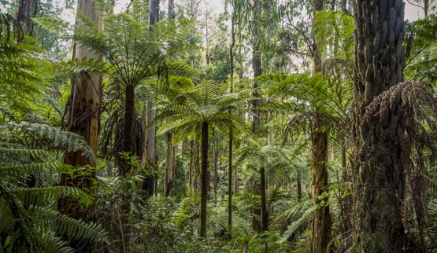

forests

b

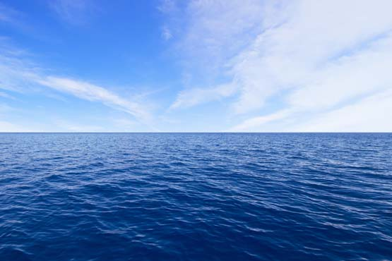

oceans

7 Other than carbon sinks, name five other places that carbon can be stored.

• decomposed organic matter such as coal, natural gas, petroleum and shale oil

• rocks such as limestone, marble, dolomite, chalk and other carbonates

• organic matter in the soil

• dissolved carbon dioxide in the oceans and other waters

• the shells of marine organisms and some terrestrial organisms

Word detective – Draw and label

8 This diagram of the carbon cycle is from page 125 of your student book, but it is missing the labels and arrows.

From your knowledge of the carbon cycle, see if you can add the labels, descriptions and arrows to the diagram. Include the ocean, atmosphere, carbon dioxide, plant material, crude oil, burning of plant material, burning of fossil fuels, aquatic organisms and so on. (Hint: Use Figure 5.17 in the student book as a guide, but try to do it yourself first.)

Student diagrams will vary, but will include similar diagrams to those in Figure 5.17 and will identify the following: geological carbon cycle: rocks, crude oil, coal, biological/physical carbon cycle: trees, animals, photosynthesis, respiration, water, carbon dioxide.

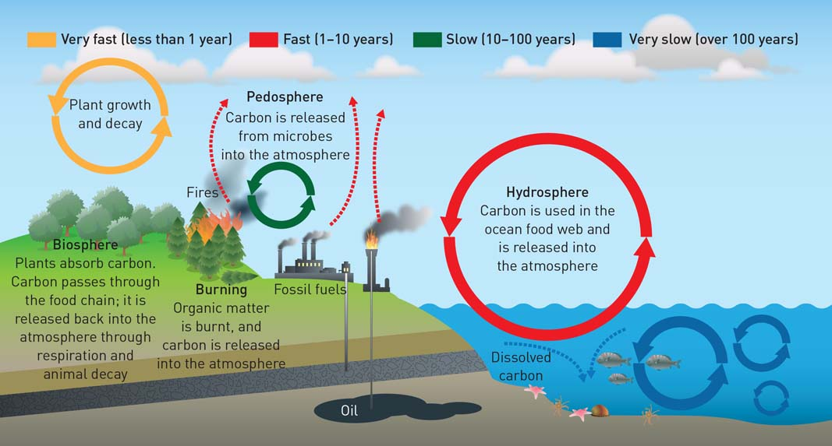

Literacy support worksheet answers

5.5 Evidence supports enhanced global warming

Pages 126–129

Evidence for global warming

1 The Earth is surrounded by an atmosphere of greenhouse gases including:

• carbon dioxide

• water vapour

• methane

2 Complete the following sentence:

‘Over the last 100 years, the average global temperature of the Earth has increased by 0.8 degrees.’

3 If heat were not trapped by the atmosphere, what would happen?

The temperature of the Earth would drop to –100°C each night and rise to 80°C in the day.

4 How long has the level of greenhouse gases been increasing, causing the enhanced greenhouse effect?

Since the Industrial Revolution of the 18th and 19th centuries.

5 What has happened to the concentration of methane in the atmosphere over the past century?

It has more than doubled.

6 The main greenhouse gas is carbon dioxide. It is formed from burning what four fossil fuels?

• coal

• petrol

• oil

• gas

7 Review the graph below, which is Figure 5.20 in the student book, and then fill in the blanks in the sentence below.

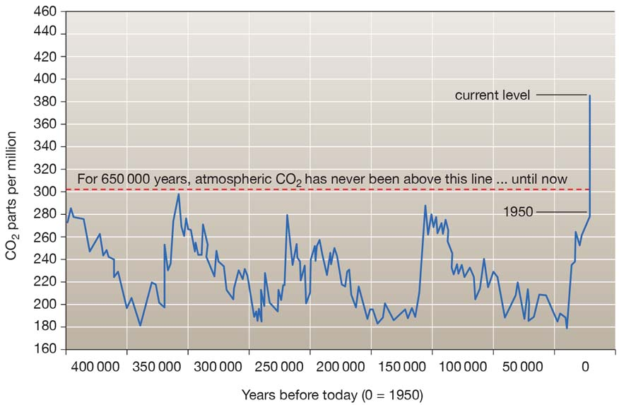

Figure 5.20 shows a significant increase in the carbon dioxide in the atmosphere since 1750.

8 Which countries are the biggest contributors to carbon dioxide emissions?

North America and China

9 Complete the following sentence:

‘Deforestation has led to an increase in carbon dioxide in the atmosphere because these forests

are no longer available to absorb excess carbon dioxide.’

10 If the Earth’s permafrost does melt, what will it release?

It will release thousands of years’ worth of carbon into the atmosphere.

Word detective – Complete the flow diagram

11 The flow diagram below is about factors contributing to human-induced climate change. Reorder the information so the flow diagram is correct.

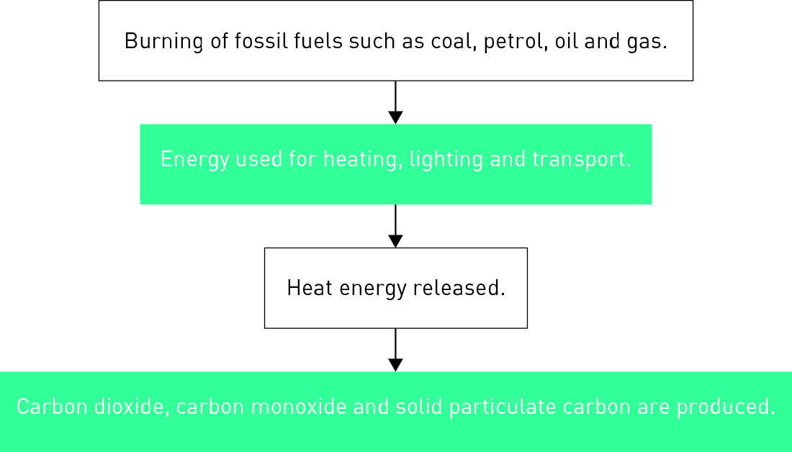

Literacy support worksheet answers

5.6 Enhanced global warming has widespread effects

Pages 130–133

Effects of global warming

1 Name three effects of an increase in global temperatures.

• an increase in the number of extreme weather events

• an increase in mosquito-borne diseases

• biodiversity is expected to decrease

2 What do scientists predict about storms as a result of climate change?

Storms will have greater maximum wind speeds and more sudden and extreme rainfall.

3 What are three extreme effects of tropical cyclones due to climate change?

• Flooding

• Landslides

• Damage to buildings

4 Fill in the blanks in the paragraph below.

A heat wave in Europe in 2003 was estimated to have killed between 22 000 and 35 000 people. Dengue fever and malaria, which thrive in warm, moist conditions, have increased incidences. Stagnant weather conditions traps warm air and pollutants, leading to smog, which results in serious respiratory problems.

5 Over the past 30 years, climate change is thought to have caused extinctions. Where are many of the species at risk of becoming extinct located?

The Arctic and Antarctica, for example polar bears and emperor penguins.

6 What is the first mammal species to have possibly been made extinct due to climate change?

The lemuroid possum

7 Fill in the blanks in the paragraph below.

The rainforests in far north Queensland may undergo a 1% increase in temperature, which may cause some species to become extinct. The loss of one species will affect the survival of other organisms. Even a small decrease in the population of a species can make it more vulnerable to disease in the future.

Word detective – Draw and explain

8 In your own words, explain how ocean currents work like a ‘conveyor belt’. See if you can include why water moves towards the ocean floor and back up to the surface, and how the top layer of the ocean evaporates. You can use the map below, from page 132 of the student book, as a guide, or refer to the paragraph ‘Deep ocean current and climate control’, also on page 132, if you need to.

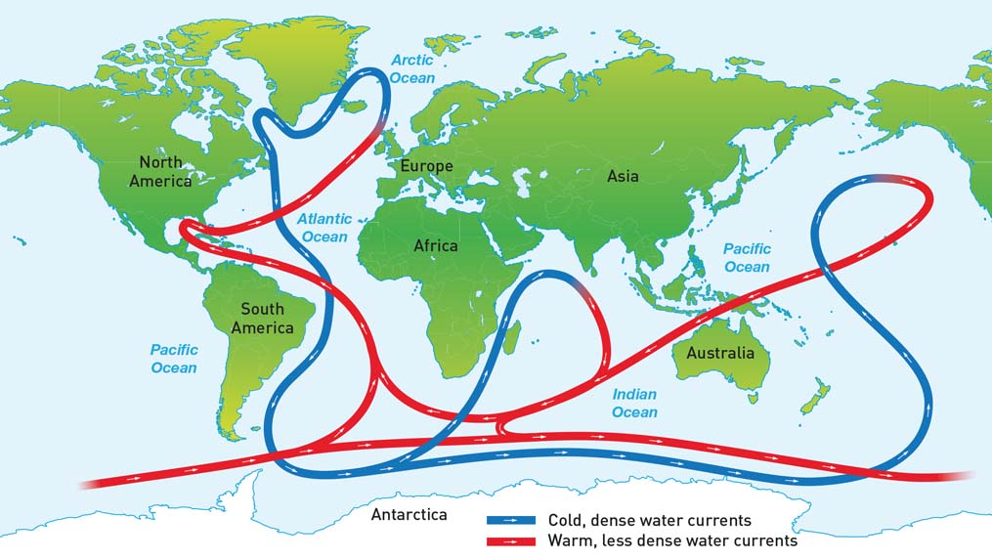

Literacy support worksheet answers

5.7 Humans can reduce global warming

Pages 134–135

Reducing global warming

1 What is the term used to describe the fee charged by the government for the carbon emitted by a business?

A carbon tax

2 Under carbon trading schemes, if a business wants to release more carbon dioxide or methane, what can they do?

Buy an allocation from another company

3 Complete the following sentence:

‘One carbon credit is often equivalent to one tonne of carbon dioxide.’

4 What is the process of capturing and storing carbon dioxide underground called?

Geosequestration

5 Sequence the process of geosequestration, a process often employed by oil companies, by ordering the following from 1 to 4.

4 The liquid is sealed with a solid plug of thick clay.

3 The liquid is pumped into depleted gas or oil wells.

1 Oil companies capture carbon dioxide from power station chimneys.

2 Carbon dioxide is separated and compressed.

6 Draw and label a diagram of a tree, to show how carbon farming works. Try to include in your diagram how photosynthesis works, where the greenhouse gas is stored and for how long, and the purpose of carbon farming.

*Student diagrams will vary.*

7 Fill in the blanks in the paragraph below.

The increase in our populations has meant more food is needed. This has resulted in more cattle, and therefore more methane being released into the atmosphere. Microbiologists are at the University of Queensland are studying ways to modify the bacteria present in the stomachs of cows so that they do not produce as much methane.

Word detective – Match the words

8 Match the following dates with the changes made to reduce global warming.

